- OVERVIEW:
As the end users may not familiar with the object models, there should be a way for them to first search for the entity (category/class) on which they want to query. For example, an end user will not know which class has the attribute for clinical diagnosis in the caTissue object model. The metadata advance search allows the users to first search for category or attributes based on metadata like names, permissible values, definition based on text or concept code.

- CLASS DIAGRAM:

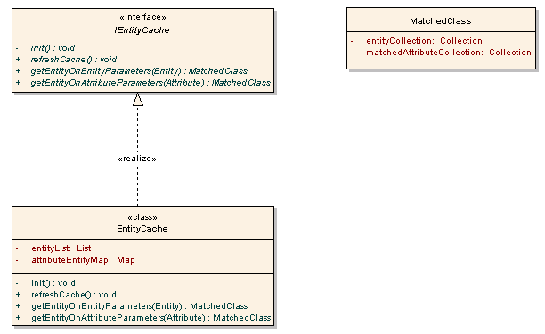

The EntityCache is a singleton class. It maintains entity and attribute information in quickly accessible manner. The data structures are populated on the first request of metadata search, using dynamic extension EntityManager APIs.
EntityCache class provides two methods for searching the entities depending on whether the search is using Entity fields or on Attribute fields. While searching on entity, the fields to be compared are populated with the search string depending on whether the search is based on text or concept code, then corresponding method in EntityCache is invoked. In these methods, the entities or attributes in the data structures are compared with the entity or attribute passed as parameter. Only not null fields in the passed object, are compared with the corresponding fields in objects present in the cache.
The comparison is achieved by extending the dynamic extension’s Entity, Attribute & its related classes to provide a new method newEquals(Entity). This method compares all the not-null fields in the parameter object with the corresponding fields in the objects in the cache.
The entities which satisfy the search comparison are added in the entity collection of MatchedClass object and the MatchedClass object is returned. In case of search on attributes, the attribute which has satisfied the comparison is also maintained in a separate collection in the MatchedClass object.

- SEQUENCE DIAGRAM:
The following sequence diagram describes the flow of control for advanced search:

